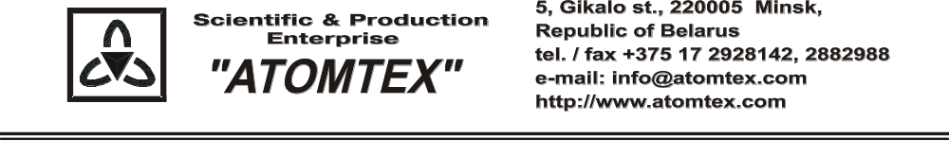
CALIBRATION CERTIFICATE

Date of calibration: 09.08.2018

Type: Detection unit BDKG-204

S/N: 438.003

Measurement limits:
BDKG-204: 0.05 µSv/h – 10 Sv/h;

Measurement error:
BDKG-204: ± 20 %

Operating conditions:

Air temperature +21°C
Atmospheric pressure 99,5 kPa
Relative humidity 77 %

The instrument is calibrated on the standard dosimetry facility AT-130, N 015, error ±4% (the Certificate of Compliance N 210-1099/15 on 23.10.2015 issued by FGUP "D.I.Mendeleyev VNIIM", St. Petersburg, Russia); AT-110, N 013, error ±5% (the Certificate of Compliance N 210-1098/15 on 23.10.2015 issued by FGUP "D.I.Mendeleyev VNIIM", St. Petersburg, Russia).

Calibration data
BDKG-204 ()
Conventionally true value (CTV) of dose rate,  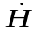*o_{i}(10) | Calibration data,  *_{i}(10)
0.70 µSv/h | 0.68 µSv/h
7.0 µSv/h | 7.0 µSv/h
70.0 µSv/h | 69.0 µSv/h
0.70 mSv/h | 0.68 mSv/h
7.0 mSv/h | 7.0 mSv/h
70.0 mSv/h | 70,0 mSv/h
0.7 Sv/h | 0.70 Sv/h
7.0 Sv/h | 7.2 Sv/h
10.0 Sv/h | 11.3 Sv/h

Calibrated by: V. Pisarenko _____________
(signature)

Technical control: N. Kurbatova _____________
(signature)

